AMARANTH Weight Manipulation Forecasting Linear Regression

Scenario Development

Adversary Attributes and Capabilities
Dragonfly has been seen targeting industrial control systems (ICS) within the electric utility sector through browsing file servers and ICS/ Supervisory Control and Data Acquisition (SCADA) files through network share discovery (T1135). Through Supply Chain Compromises (T0862), Dragonfly has trojanized installers for control system software on vendor app stores (T1195). They have also been seen using watering hole attacks on the energy sector websites by injecting a redirect iframe to deliver backdoors or trojans (T0817).

Adversary Goals
Dragonfly has a significant interest in both observing how energy facilities operate as well as gaining access to operational systems, up to the point of gaining control or sabotage (https://www.security.com/threat-intelligence/dragonfly-energy-sector-cyber-attacks).
The goal of Dragonfly seems to be reconnaissance focused but has shown potential to cause impact including loss of energy, including harm to corporate reputation and customers reliant on distribution providers (https://www.giac.org/paper/gicsp/724/impact-dragonfly-malware-industrial-control-systems/148912).
[POSTULATED] Goals of this specific attack are to evade detection but cause load forecasting to drop below reserve capacity to cause blackouts for the city of Austin TX through AI-based attacks.

Adversary Infrastructure
In the case Dragonfly decides to attack a ML-based forecasting framework, using the techniques described above, Dragonfly would conduct supply chain attacks through vendor software on the ML-forecasting system.
If we assume the vendor provides an ICS device which is pretrained and a “black box” model, as shown below, we can assume the point of entry for Dragonfly is an update or trojaned software in the ICS forecasting system.
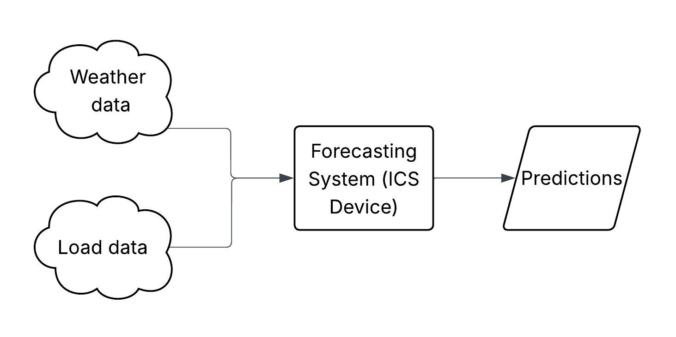
We assume the ICS device architecture to look similar to the proposed RISC-V architecture used in the automotive sector: 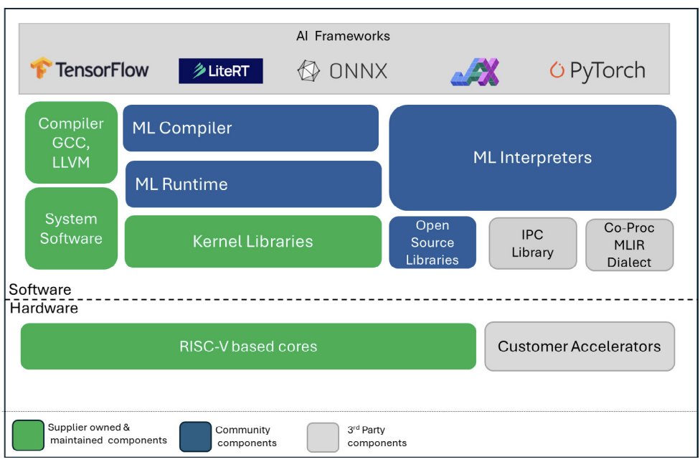
https://riscv.org/wp-content/uploads/2025/04/RISC-V_AIOpportunitiesChallenges_042825.pdf
As shown in the figure above, there is multiple points of entry including the community components and the supplier owned and maintained components. Using the AI frameworks being on the chip itself and saved in presumably an ONNX file structure as it is used as an ML interpreter, we can assume the Dragonfly pushes out a trojan version of a supplier forecasting model update through the vendor app store with the ML trojan existing within an ONNX file.
This requires Dragonfly to have the infrastructure to manipulate the AI model prior to productizing the trojan including compute resources and an exfiltrated original model, gained from the vendor or the industry partner.

Adversary Capabilities
The connections to the predictions output and the inputs of the load data allows Dragonfly to inform what periodicity of the forecasting model. In this instance, the model needs to not be impacted significantly for 120 days following update to evade detection. Dragonfly will require a method to put up the infected model on the vendor app store as well as a method to pull the original model to determine the differences and how to reconstruct the impact. By conducting reconnaissance on the industry partner’s inputs and the original architecture from the vendor, Dragonfly can create a trojaned version and host it back on the vendor app store.

Walk Through an Attack Path
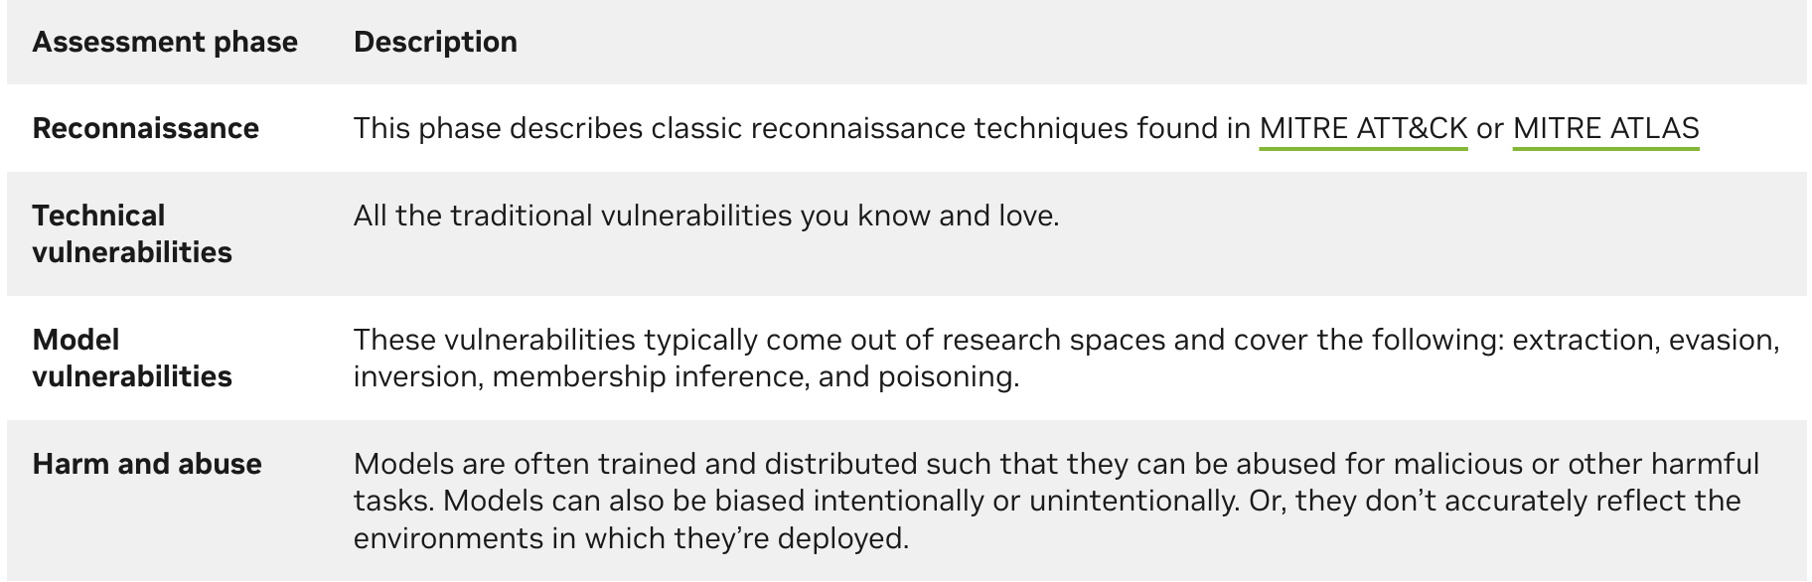

Reconnaissance
How can the adversary get the information they need on their target? Are there passive or active methods of getting the information they need?
Passively, Dragonfly can obtain historical load and weather data from open-source information. Actively, Dragonfly will need to obtain the original model architecture or weights prior to this attack from a vendor or industry partner. They will need to refine their target.

Technical Vulnerabilities
The vendor app store must be exposed and allow for uploads to work for Dragonfly to add their trojaned model. The vendor must have a version of the forecasting model uploaded to the store for others to see for Dragonfly to deconstruct and reconstruct the model. Additionally, the model needs to be updated via an automated API call or a manual upload of the trojaned version to the ICS device.

Model Vulnerabilities/Manipulation
Manipulation will be conducted through downloading the model architecture from the ICS device or the vendor as an ONNX model,
Meat of the activity. We will focus on these attacks specifically. How can they be done? Focus on post-deployment models.
1. Model inversion.
2. Architecture manipulation.
3. Weight manipulation.
4. Seed manipulation.

Impact (Harm and Abuse)
What is the potential impact on the model? How does it affect the system more broadly? Does it affect people or the surrounding “environment”? What is required to do these impacts?

Conduct Exercise
Conduct the exercise, focusing on model vulnerabilities/manipulation, keeping focus on the adversary’s attributes and capabilities and collect data. Remember to keep a “clean” version of the original model and infrastructure.
Start from model vulnerabilities and manipulation, going to impact. If possible, work through the entire attack path if given enough time.

Timeline
- Through attack path prior to model manipulation, model ONNX save file was accessed as well as a snippet of real-time data.
- ONNX file was deconstructed and inferenced on real-time data.
  - Weights are stored in onnx model, graph, initializer, ‘coef’, parsed out by each layer and neuron/feature.
- Randomize weights based on presumed weight range
  - For Linear Regression, weights seemed to go between -1 and 1.
  - Using random.uniform, generate the number of neurons per layer or features on the first layer.
- Save model into another file to be read and inferenced on by ONNX InferenceSession.
- “Score” the modified weights after running through InferenceSession.
  - If normalized (monthly basis) modified model has a higher value at the normal drift position than the original model, save the weights and model.
  - Iterate multiple times (100 for now), appending weights and a model to arrays.
  - Determine “best model” according to adversary goals
    - For the first year, find the model with the closest L2 score to the original dataset.
    - Find the model with the lowest MAE.
  - Calculate the new KL-divergence
  - Plot the new forecast and old forecast

Results
The results of the attack resulted in a shift of KL-divergence overtime, where the model does drift significantly sooner than the original model. The original model has a medium drift point at September 2020 whereas the adversarial manipulated model has a medium drift point at December 2017.
Despite this drift, the adversary was successful in making the mean absolute error (MAE) be similar to the original model and the first year of the adversarial model to be nearly the same as the original model. After the first year however, the adversarial model significantly over forecasts load and then under forecasts load, causing load balance issues of the model.
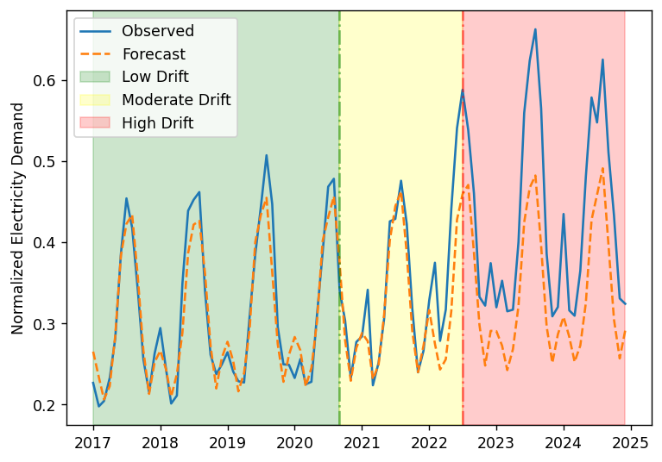
Figure 1. Normal Linear Regression Forecast.

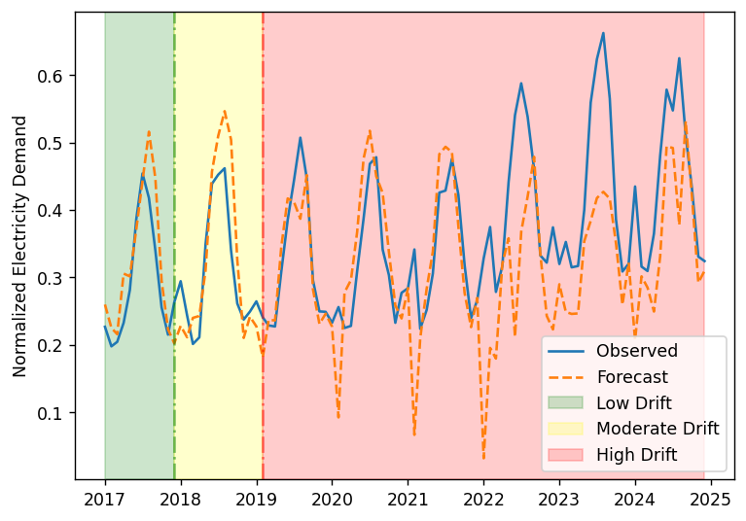
Figure 2. Modified Weights Linear Regression Forecast.

Impact on Confidence Intervals
N/A. Need to figure out how to do residuals prior to this.

Impact on Accuracy/Error
MAE went from 0.04605 to 0.068204. Only a 2% change.

Impact on KL-Divergence
The original model has a medium drift point at September 2020 whereas the adversarial manipulated model has a medium drift point at December 2017.

Plausibility
How plausible is this? Answer these questions:
- Does it sound like a technical vulnerability caused the issue, or a model vulnerability more so?
  - Model vulnerability caused this issue. Weight manipulation is only possible with being able to reconstruct or store model weights. The access to the model saves or the computer does not ensure adversarial success. ONNX stores all this.
- Does this affect any ML processes?
  - Yes. This effects the ability of the forecasting model to predict load accurately, causing significant under or over prediction, potentially causing blackouts.
- Who is responsible for the models? Would they know if changes have been made?
  - The balancing authority (?) is responsible for load forecasting. They would know changes have been made if the SOC sees the entry point into the inference system or physical effects are made and unexpected.

Potential Controls
Identify potential controls and countermeasures to manage vulnerabilities and impacts (or risks). You don’t have to test these.
Potentially have a traditional (like SARIMA or physics-informed model) to provide a secondary or tertiary check for the load forecasting states.
Managing ONNX or choosing another framework would be recommended, due to the high level of vulnerabilities: https://security.snyk.io/package/pip/onnx.
Additionally, a threshold of acceptable capacity and reserves (as already created) on top of the projected load should be used to ensure blackouts are not achieved.

